Natalie Cabayan

01.08.2019

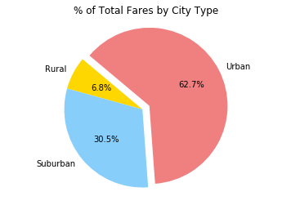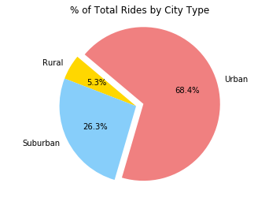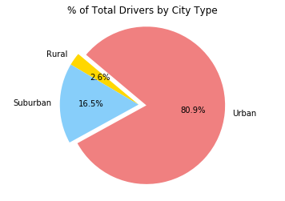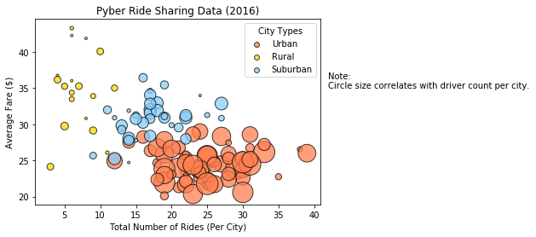**Pyber Analysis**

1. Most drivers are in Urban cities
2. Most of the fares and rides are from Urban cities
3. Rural cities are account for the smallest number of fares, rides and have the least amount of drivers.